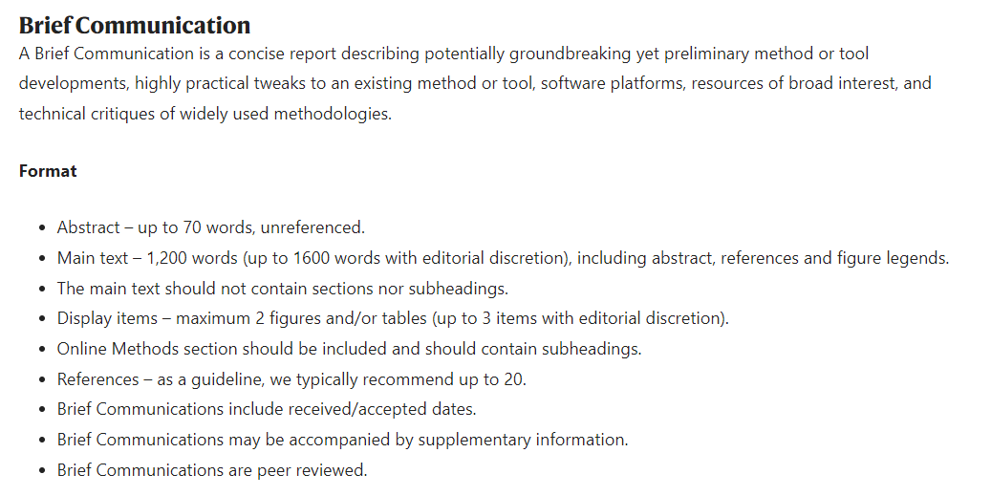

Abstract

Multiplex imaging has proven to be very useful in gaining insight into complex biological systems. The most common and accessible open-source methods are based on fluorophore bleaching and have proven to be labor and time intensive methods. Here, we report a new automated multiplex imaging platform that employs a novel fluidic device to stain tissue on slides and a much faster fluorophore bleaching solution.

Article

Fluorescence microscopy has proved to be invaluable for biological research. However, fluorophores intrinsically have broad excitation and emission spectral bandwidths. This limits the number of unique markers that can be distinguished reliably from each other. Currently that limit is 4 and can be 5 on special higher bandwidth systems. This poses significant limitations on biological studies as biological pathways are highly intertwined and yet for any sample, we can only label 4 of those components at once. A typical strategy to increase marker count is to use different markers on different samples and aggregate their results together. However, this is far from ideal given noise in biological system are high and many results are subject to local properties and conditions of the system. A strategy to further dampen this impact is to use adjacent slices in a tissue sample with different markers. Still at best this is a Riemann sum getting closer to the integral result. Having all markers on the exact same tissue slice would reduce the biological noise to a minimum and thus be a more ideal way to study many biological systems.

Current multiplexing strategies have a range of drawbacks primarily in the realms of cost and labor. The codex system is the most well validated system and the only commercial system available. Its labor is low, but cost is high. On the opposite end of the spectrum are cyclic fluorophore bleaching methods. These methods are labor intensive, but relatively cheap and use easily obtainable reagents. In this paper we present a new microscope that automates the cyclic bleaching technique via an upright viewable fluidic slide tissue staining device as well as a new fluorophore bleaching solution that drastically reduces bleaching time and is compatible with fluidic systems as it is bubble free by nature.

We identified the broadly defined major labor barriers as being getting the tissue back to its previous spot for each cycle and doing any fluidic exchanges on the tissue such as washings, bleachings and stains. The first barrier is easily addressed if the slide is never physically removed from the stage, thus all steps in the method must occur on the stage. The second barrier is much more difficult to overcome. Small volumes over the tissue are needed to conserve staining reagents, fluid must always be present over the tissue to prevent dehydration and whatever is used must be reusable. It is easy to envision microfluidic device that can accomplish this, but traditional devices are not compatible as they are made to be unremovable, and imaging is typically performed through the glass substrate. Imaging through the PDMS device or glass slide are not options as they would greatly limit our max achievable resolution due to their thickness and high refractive indices. We accomplished our goal by creating a PDMS based, removeable fluidic device that contains a viewing window in its ceiling made from FEP film which was sealed to the glass slide with a magnetic force-based pressure plate that was placed above the device. FEP is an idealistic material to use for this application as water must always be above the tissue to prevent dehydration and FEP film is thin and has the exact RI of water. By using an upright water dipping microscopy system, we were able to not only boost our resolution due to the increased RI of water, but effectively make the FEP film viewing window invisible.

To test the fluidic device, we flowed antibody stain for alexa-647 Na/K/APTase into the device and imaged the tissue every minute. We found that the emission fluorescence was stable in non-tissue parts of the image, which indicates that we are not getting more dilute over time and it shows that the stain did bind to the tissue. An interesting application of this is monitoring the binding kinetics of the stain with the tissue. Additionally, the background fluorescence levels return to previous levels after flushing the device with PBS, indicating that wash cycles are very effective.

The primary fluorophores used in these methods are cyanine based like alexa-555 and alex-647. Even though alexa-488 is rhodamine based, it is used as the green channel fluorophore as no equivalent cyanine based dyes exist and it is still mildly susceptible to the same bleaching solution. High pH hydrogen peroxide was originally used as the bleaching chemical, but that proved very slow with it needing over an hour to bleach alexa-488. Switching to Lithium borohydride in the IBEX method greatly sped this process up to around 7 minutes. Unfortunately, both chemical solutions are incompatible with sealed fluidic devices as they produce bubbles. These cannot be degassed as chemical reactions in the solutions themselves cause these to be formed. If the bleaching chemical reaction was known, we could identify new chemical candidates and determine if any of them had properties compatible with microfluidic systems. We propose the bleaching chemical reaction is the prilezhaev reaction followed by the formation of epoxide groups. This led us to identify meta-Chloroperoxybenzoic acid (mCPBA) as a potentially ideal bleaching solution as it does not intrinsically produce bubbles.

To test the chemical reaction speed of mCPBA, we performed a fluorescence based, multi-well plate assay by adding MCPBA, LiBH4 and H2O2 into solutions of secondary antibody solution conjugated to the rate limiting alexa-488 dye. We found that mCPBA was not reactive with any additional dyes, but was much faster than either LiBH4 and H2O2. After adjusting for working concentrations, mCPBA is roughly 2 times faster than LiBH4 at bleaching alexa-488 and 20 times faster than H2O2. To further demonstrate this, we compare tissue stained with ezrin alexa-488 and bleached for 3 minutes in each solution.